Installing Microsoft Project on a personal device using Azure Dev tools
Go here: https://azureforeducation.microsoft.com/devtools
Sign in with your UWE account and complete account details if required
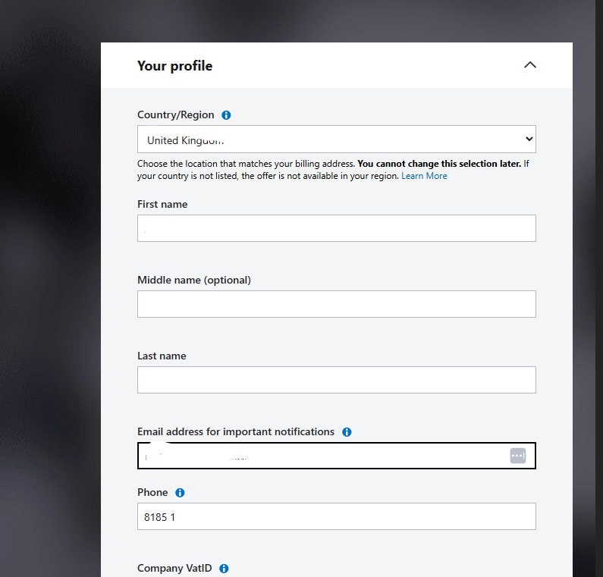
Go to the software tab and search for ‘Project’
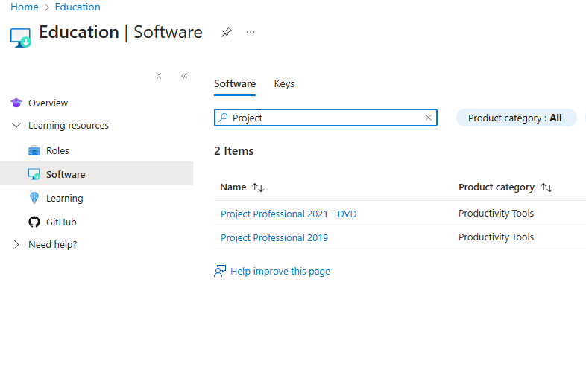
Click on Project Professional 2021 – DVD and select ‘Download’. Also Select ‘view key’ and copy the product key it generates.
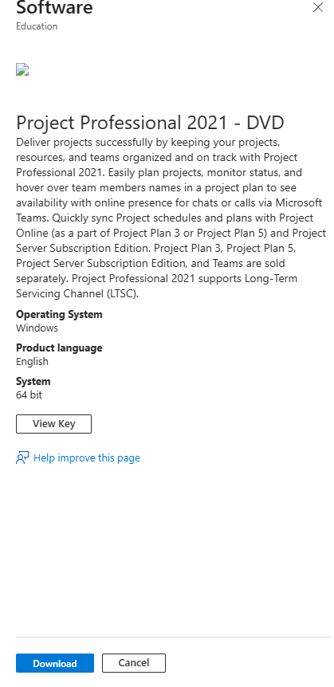

Open the folder containing the downloaded ISO file.
Double-click the file to mount it in a virtual drive, which you can see a short moment later in the left-side menu of the Explorer. Alternatively, right-click the ISO and press ‘Mount’ from the pop-up menu.
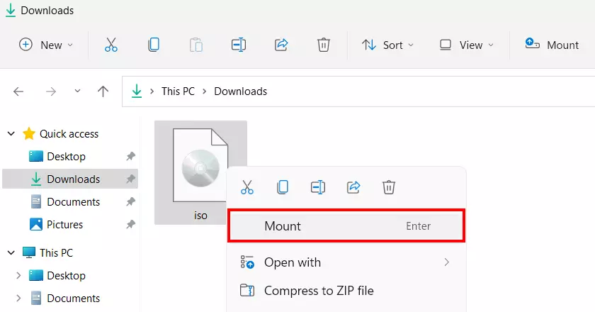
Make sure you have closed any other Microsoft applications. Open the virtual DVD drive and double click ‘Setup’.
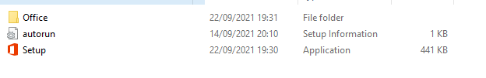
Once Setup completes, launch Microsoft Project for the first time. It will prompt you for a product key. Use the key you copied earlier to register the product and start using it.
